
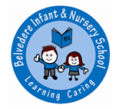
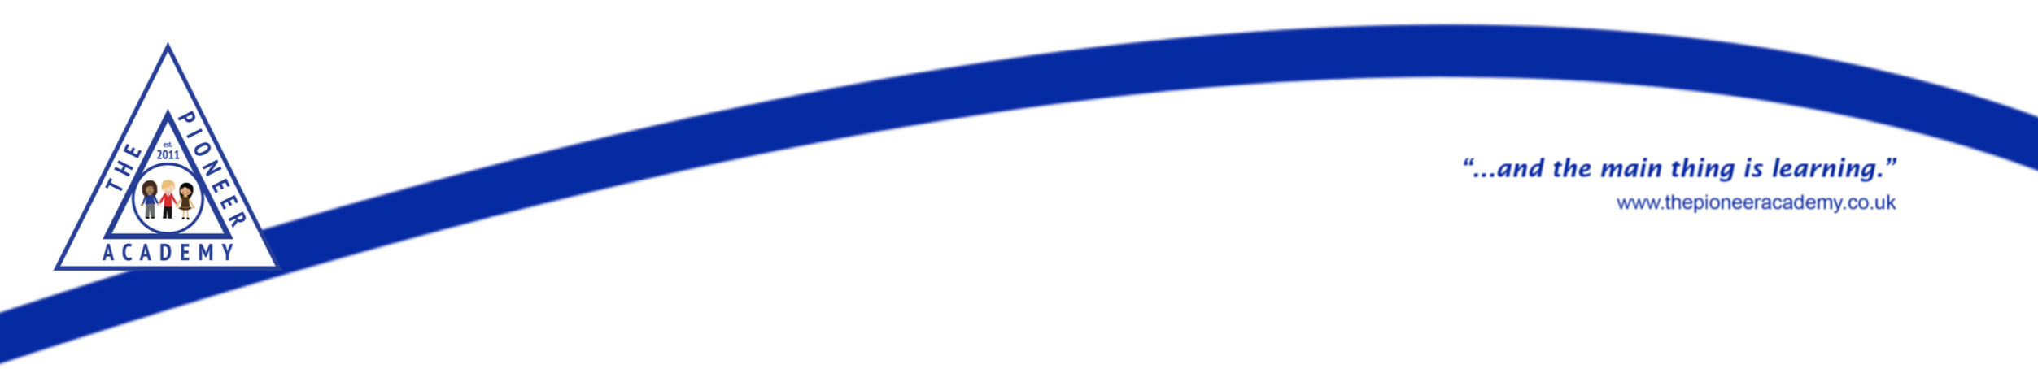



Year 1 Summer 1 Newsletter

We hope you had a lovely Easter break and are ready for another brilliant half-term in Year One. Our topic is ‘Green Fingers’ and we will be exploring plants and climates around the world.
English
In Writing, the children will be exploring pattern and rhyme within poems. They will then write their own poems taking inspiration from one we have read. They will build on their developing knowledge of letter writing to plan and write informal letters allowing them the opportunity to apply their growing grammatical knowledge. The children have worked hard on descriptions and using adjectives and they will apply this knowledge to write a detailed setting description. These opportunities will give them the opportunity to apply the writing skills they have learnt so far this year: capital letters; finger spaces; full stops; exclamation marks; question marks; adjectives; using ‘and’ to extend sentences and writing sequences of sentences.


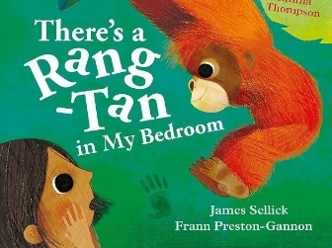
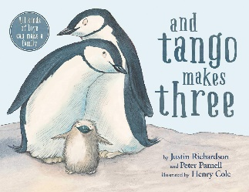
Maths
In Maths this half term, the children will learn about how to recognise and find fractions. The children will be taught how to find halves and quarters of shapes and quantities. This will build on their knowledge of sharing that they acquired last half term. They will be introduced to simple standard and non-standard units of measurement. They will measure and compare length, height, mass and capacity.
Phonics/Reading
Children will continue with their daily phonics sessions following the Little Wandle Scheme. As we have the phonics screening check coming up in June, children will revisit and revise previously taught sounds to consolidate their knowledge of these sounds.
Our focus texts in our reading sessions this half-term are: ‘There’s a rang-tan in my bedroom’ and ‘And Tango makes three’.

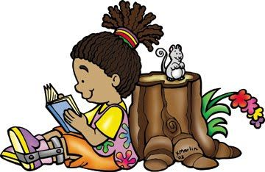
Reminders
Please ensure that your child is in the correct uniform and that every piece of your child’s uniform is clearly named so that we can identify any items that may get misplaced. Earrings and jewellery must not be worn to school for health and safety purposes. Please ensure children bring their book bag with their reading book and yellow reading record every day.
Now the weather will be getting warmer, please make sure children have a named water bottle and hat in their bag.

PE Days
Rubik: Tuesday/Thursday
Simmonds: Thursday/Friday
Franklin: Wednesday/Thursday
PE kits should include plain blue shorts or black/blue/grey tracksuit bottoms, a plain white t-shirt and plimsolls or trainers. Children should come to school dressed in their PE kit on PE days.

Important Dates
Scholastic Book Fair – Friday 25th – Wednesday 30th April
Half-term – Monday 26th – Friday 30th May
Inset Day – Monday 2nd June
Y1 trip to Mudchute Farm – Tuesday 17th June

How you can help your child at home
We believe that parents and carers must foster their child’s love of learning by regularly listening to them reading aloud and by checking in with what their children are learning at school on a daily basis.
- Reading books are changed weekly and we encourage children to read regularly at home (please make a note of this in your child’s reading record)
- Practise reading and writing the ‘tricky-words’ frequently
- Adults to support children’s writing at home by ensuring the correct letter formation and pen grip is being used
- Represent numbers to 50 in different ways at home
- Identify numbers within 50 in different place e.g. on door numbers, buses etc.
- Count in multiples of 2, 5 and 10

Homework
Homework books will be sent home every Friday and are to be returned the following Wednesday. There will be a sheet containing all the homework for Summer 1. Each week, we would like the children to select one of the homework tasks and complete this in their homework books. You do not have to complete all of the homework provided by the end of Summer 1, just one per week.
Spellings will be given at the beginning of the term to learn over the next 6 weeks.

Topic – Green Fingers
Our topic this half term is ‘Green Fingers’. The children will be learning all about plants and what they need to grow. They will carry out various scientific investigations and use their observation skills to record and analyse their findings. They will find out about what happens to plants if they don’t get what they need as well as finding out about their lifecycles. Linked to this, in Geography they will look at different climates and find out about plants that can grow in different places.

